Community Emergency Scheme

 Overton,

incorporating

Sunderland Point;

Community Emergency Plans

Public Version 1.7

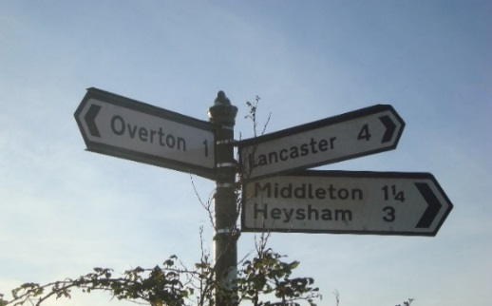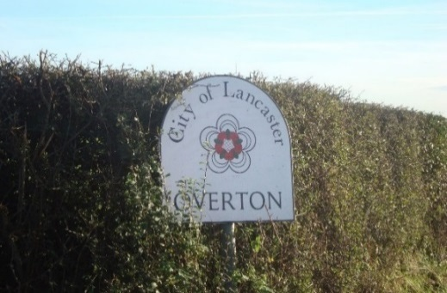

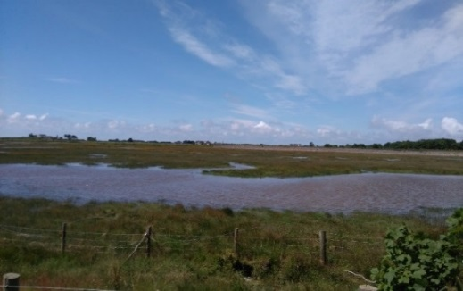

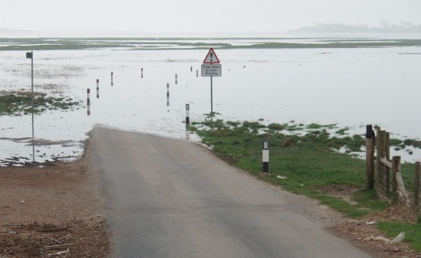

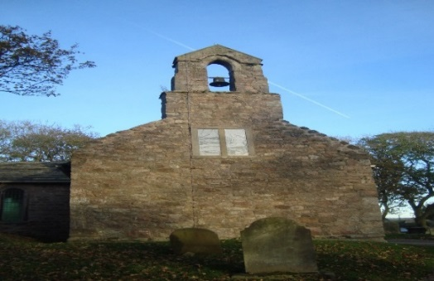 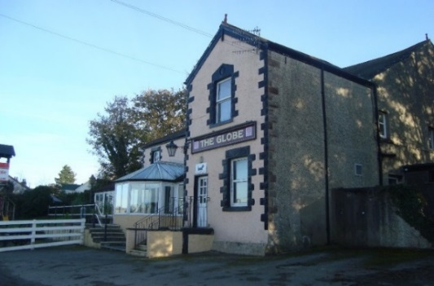

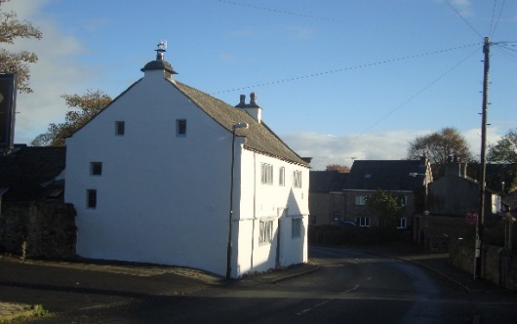 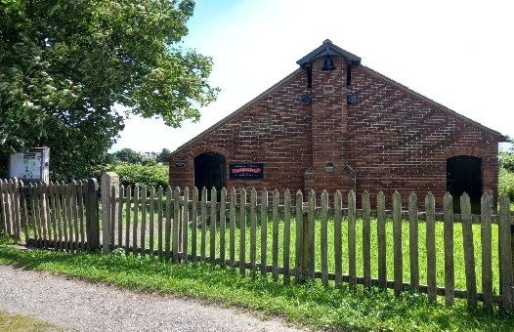

# Contents

|  |  |  |
| --- | --- | --- |
| **Section** | **Details** | **Page** |
| Rationale | Why a Plan? | 3, 4 |
|  | Plan Ownership | 4 |
|  | Distribution | 5 |
|  | Structure of Document and Amendments | 6 |
| 1 Information (Overton) | Overton Village | 7 |
|  | Maps | 7 – 10 |
| 2 Intention (Overton) | Purpose and structure | 11 |
|  | “H” signs | 12 |
|  | Quick help reference | 12 |
| 3 Method (Overton) | Activation triggers | 13 |
|  | Initial actions | 13 |
|  | Local risks | 14 |
|  | Additional information/Actions | 15 |
|  | Volunteer Support | 16 |
|  | Local Skills | 16 |
|  | Alternative contact information | 17, 18, 19 |
|  | Community Response | 19 |
|  | Resources | 20, 21 |
|  | Key safety locations | 22 |
|  | Community organisations | 23 |
| Personal contact information only available on Confidential version; call 07917 181060 for details. | Emergency coordinators | 59 - 62 |
| Vulnerable list | 63 |
| Volunteer support | 64 |
| 4 Administration (Overton) | Administration | 23 |
| 5 Communication (Overton) | Communications | 23 |
| 6 Public Health Alerts | Notes | 24 |
|  |  |  |
| Sunderland Point Plan | Detailed contents p26 | 25 – 48 |
| Sunderland Point Plan Contents |  | 26 |
|  |  |  |
| Policies, Task Sheets etc. | Policies, “H” Sign, Phonetic alphabet  Emergency log, Task sheet, Authorisation | 49 – 57 |
| Confidential information | Confidential version only | n/a |
|  |  |  |

**Why do we need a Community Emergency Plan?**

The Overton and Sunderland Point Community Emergency (Initial Response) Plans will be implemented either in extreme circumstances that prevent emergency services from reaching Overton or Sunderland Point quickly or in such cases that support be otherwise required. In either case the initial response may rely entirely on residents. The plans describe how such responses might be co-ordinated.

It is a “hands-on” working document.

The plans call for the villages to have residents acting as volunteers and emergency coordinators. Having several emergency coordinators should mean that it is likely that at least one emergency coordinator is in, or close to, the village at any one time. Sunderland Point, whether one regards it as a part of Overton or a separate entity, has its own unique situation and needs. However liaison between the groups and support where possible are vital.

There are emergency plan secretaries, who administer the plans.

Other village groups, including volunteers, have offered their support.

Anybody who would like to assist is always warmly welcomed as a team member.

It is recognised that in any extreme situation people of the village working together have the best chance of a positive outcome.

The plans themselves are supported by training and other documentation.

The main point of contact and information regarding the Overton sections of the plan is [mctague.michael@gmail.com](mailto:mctague.michael@gmail.com) 07917 181060 and for the Sunderland Point sections Ted Levey 01524 858442 or 07434 736067.

*If vulnerable members of the community or people with particular needs would like their contact information to be held as high priority, and in confidence, they should contact their Emergency Plan Secretary. This information would only be seen by the Emergency Plan secretary and emergency coordinators and only be available in confidential versions of the plan held by the city council and the emergency services.*

Most emergencies are be dealt with by the emergency services, local authorities, utilities and voluntary agencies in a combined response. These plans are not intended to be a substitute for these services. Should an emergency situation arise the first action would always be to contact the emergency services by **dialling 999**.

The plans also cover circumstances such as flooding, extreme weather, loss of services including electricity, water, gas or telephone, where the emergency services may not be immediately required.

# PLAN OWNERSHIP

|  |  |
| --- | --- |
| **Name** | **Overton Emergency Plan Working Group** |
| **Plan owners** | Michael McTague  5 Chapel Lane, Overton, LA3 3HU  07917 181060  William Morris  Community Contact Coordinator  11 First Terrace, Sunderland Point, LA3 3HR  07527 124777  Kirstie Banks-Lyon  Resilience and Community Safety Officer, Lancaster City Council  01524 582385, 07887 831134 |
| **Version** | **Version 1.7** |
| **Date** | **June 2024** |

**The plan owners are responsible for ensuring the plan remains up to date and**

**for the distribution of hard and digital copies.**

**At the minimum, the plan owner, coordinators, The Reading Room, The Overton and District Memorial Hall, Overton Parish Council, St Helen’s Primary School, Lancaster Council and nominated residents should keep a hard copy of this document available for use in the event of the plan being activated.**

**We are grateful for the support of Lancaster Council, in particular to**

**Mark Bartlett and Kirstie Banks-Lyons, Civil Contingencies Officers.**

The **Resilience and Community Safety Officer** at Lancaster City Council will ensure that electronic versions of this plan are forwarded to:

Lancashire Constabulary

Lancashire Fire and Rescue Service

North West Ambulance Service

Lancaster City Council (Control Centres and Duty Emergency Incident Officer)

Lancashire County Council Emergency Planning

Maritime & Coastguard Agency

RNLI (Morecambe)

Environment Agency

# Distribution

|  |  |  |  |
| --- | --- | --- | --- |
| **1 - Name** | Coordinators | **Date Sent** | 27 06 2024 |
| **Address** | See details on pages 59 - 62 | | |
| **Tel. Contact** | See details on pages 59 - 62 | | |

|  |  |  |  |
| --- | --- | --- | --- |
| **2 - Name** | Volunteers | **Date Sent** | 28 06 2024 |
| **Address** | See details on pages 64 | | |
| **Tel. Contact** | See details on pages 64 | | |
|  |  | | |
| **3 - Name** | Overton Parish Council | **Date Sent** | 27 06 2024 |
| **Address** | The Overton and District Memorial Hall, Middleton Road, Overton, LA3 3HB | | |
| **Tel. Contact** |  | | |

|  |  |  |  |
| --- | --- | --- | --- |
| **4 - Name** | Overton and District Memorial Hall Committee | **Date Sent** | 27 06 2024 |
| **Address** | The Overton and District Memorial Hall, Middleton Road, Overton, LA3 3HB | | |
| **Tel. Contact** |  | | |

|  |  |  |  |
| --- | --- | --- | --- |
| **5 - Name** | The Head teacher | **Date Sent** | 26 06 2024 |
| **Address** | Overton St Helen's Church of England Primary School  Lancaster Rd, Overton, LA3 3EZ | | |
| **Tel. Contact** | [01524 858615](javascript:void(0)) | | |

|  |  |  |  |
| --- | --- | --- | --- |
| **6 - Name** | Reading Room, Sunderland Point | **Date Sent** | Paper copy to follow |
| **Address** | OS Map Reference SD 425560 | | |
| **Tel. Contact** |  | | |

|  |  |  |  |
| --- | --- | --- | --- |
| **7 - Name** | Kirstie Banks-Lyon | **Date Sent** | 20 06 2024 |
| **Address** | Civil Contingencies Officer,  Morecambe Town Hall, Marine Rd East, Morecambe LA4 5AF | | |
| **Tel. Contact** | 01524 582385 resilience@lancaster.gov.uk | | |

# Record of amendments

Ensure annual reviews and amendments are recorded here.

Please notify the Civil Contingencies Officer at Lancaster City Council immediately of any changes and distribute accordingly.

|  |  |  |
| --- | --- | --- |
| **Amended by** | **Signature**  **and date** | **Signature**  **and Date** |
| Michael McTague  and  Ted Levey | msotw9_temp0  June 2024 | June 2024 |
|  |  |  |
|  |  |  |
| **Note** | Sunderland Point Plan tested Exercise Trumley on 6th December 2010  Other plans tested 10th October2017, Operation Moorgarth  and 15th October 2018 | |

# Structure of these documents

***The scheme is separated into the following sections:***

***1 Information – general background information***

***2 Intention – what the plan is intended to achieve***

***3 Method – how the scheme’s aims will be achieved***

***4 Administration – of the scheme***

***5 Communications – radio, telephone etc.***

***6 Public Health Alerts***

***7 Appendices – more detailed information about specific matters***

Section 1 Information

**Community Profile**

The Parish of Overton occupies the southern end of the peninsula between the river Lune and Morecambe Bay, and is itself divided into two parts by an arm of the river. The western part is called Sunderland, formerly one of the landing-places of the port of Lancaster; the eastern part is Overton, with Bazil Point jutting into the Lune at the south and Colloway on the higher land,100 feet above sea level, at the north. From the village of Overton, lying near the centre of the main part, roads spread out in various directions: north to Heaton, south to the St Helen’s Church and the riverside, (where there was once a ferry to Glasson). South-west to Sunderland Point, (impassable when road is covered by the tide) and north-west to Middleton.

The population is 1069 (2011).

The area is 1,837 acres including 43 of salt marsh.

**Map 1**

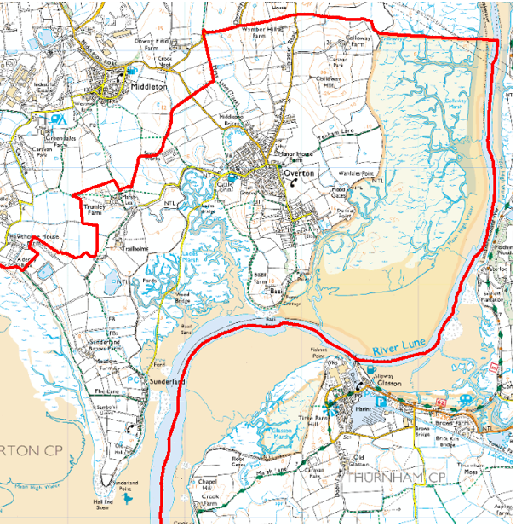

**Map 2**

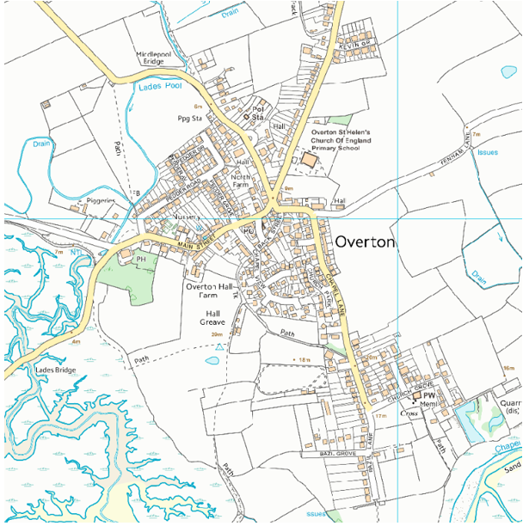

Note: This map will be replaced once an up-to-date version becomes available.

Land between Kevin Grove and St Helen’s school now is odd nos. 23 - 85 (inclusive) Lancaster Road

**Map 3**

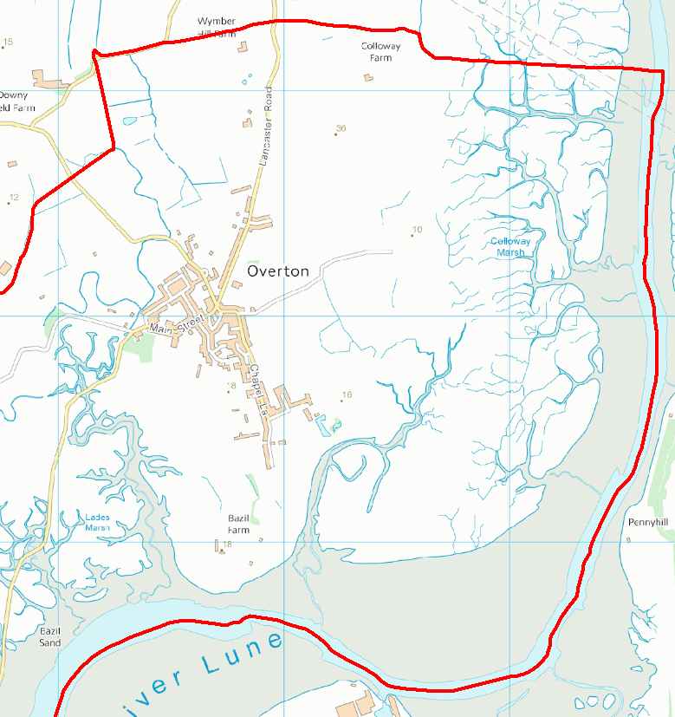

**Map 4**

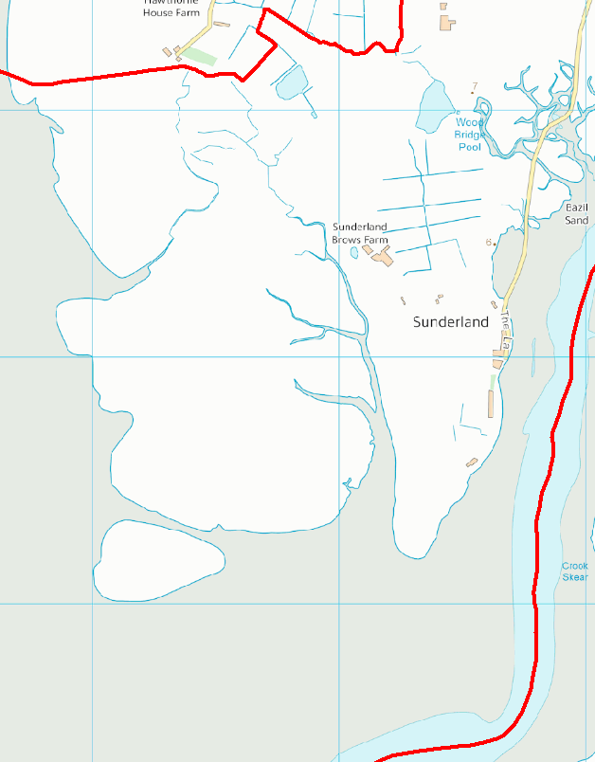

# Section 2 Intention

The purpose of the plan is to cater for extreme circumstances that might prevent the emergency services from reaching the scene promptly. In such cases the initial response may rely entirely on Overton and Sunderland Point residents; this plan describes how such an initial response could be coordinated.

The plan also covers circumstances such as flooding, extreme weather, infectious disease, loss of services such as electricity, water, gas or telephone, where the emergency services may not immediately be required.

# Structure of the community emergency scheme

Following December 2015’s flooding in the local area, resulting in a loss of power in Overton, this group was set up to develop a scheme aimed at people being supported to help each other should a similar situation ever occur. The scheme provides a framework for listing contact details, responsibilities and information about resources. It is intended to be of real help in acting at the onset of an emergency and also assist in dealing with day-to-day problems that may arise in communities such as ours.

Trained voluntary emergency coordinators will use The Overton and District Memorial Hall (The Memorial Hall), and/or other locations depending on the need, to use all the resources at their disposal to provide emergency support along with, or in the absence of, professional emergency services.

Please note that the community of Sunderland Point, due to its unique position and needs, has further specific Emergency Plans (pp 25 – 48) and the two sections of the village will support each other wherever and whenever possible.

Subsequently, the global Covid 19 pandemic of 2020 tested the nation in an unforeseen manner. Lock-downs, shielding and social-distancing created a scenario calling for completely different strategies.

# The “H” sign

Situations happen, often beyond our control, e.g. extreme weather. Local emergency services (Fire police etc.) will always prioritise those people in greatest need, especially where life is in danger. There will be times when you may be affected but you or your family’s life is not in immediate danger.

During this time, you need to know how to help yourself and those around you. By becoming more resilient, you and your community can complement the local responders and reduce the impact of an emergency on your community.

Each Overton household will be offered an emergency “Help” sign which can be displayed *at any time* when assistance is needed. If you see one of these please try to assist, but if it is a life-threatening situation, dial 999 immediately for the emergency services. See Appendix page 54.

|  |  |
| --- | --- |
| Quick help and advice – some really useful sites: | |
| Lancaster City Council Community Hub:  Food bank  Mental Health  Advice  Housing  Support…….. | * <https://www.lancaster.gov.uk> * choose “Community Hub” then select as required |
| Police and safety | [www.stayintheknow.co.uk](http://www.stayintheknow.co.uk) |
| Healthcare | [www.nhs.uk](http://www.nhs.uk) |
| Local hospitals | [www.uhmb.nhs.uk](http://www.uhmb.nhs.uk) |
| Defibrillator sites | https://www.defibfinder.uk/ |
| Government advice | [www.gov.uk](http://www.gov.uk) |
| News (copy link on right, choose “News”) | [www.beyondradio.co.uk](http://www.beyondradio.co.uk) |
| Preparing for emergencies | [www.lancashireprepared.org.uk](http://www.lancashireprepared.org.uk) |
| Roads  (choose “Road works bulletin”) | [www.lancashire.gov.uk/roads-parking-and-travel/roads](http://www.lancashire.gov.uk/roads-parking-and-travel/roads) |

# Section 3 Method

### Emergency Coordinators will activate the plan following an activation trigger such as:

1. Local flood warning (coordinators receive MET Office updates by email and are aware of the Environment Agency’s flooding plans, alerts and warnings.
2. When Emergency Services contact an Emergency Coordinator.
3. When Lancaster City Council or Lancashire County Council Emergency Planning Officer contacts an Emergency Coordinator.
4. Loss of supplies such as water, gas, electricity, telephone.
5. Major accident or disease (such as Covid 19 pandemic).
6. Declaration of a Nuclear Emergency by Heysham Power stations, requiring evacuation or directions to stay at home.

### They will activate the plan following the routine outlined in the Training Manual (see appendix 1):

# Initial actions for Emergency Coordinators

|  |  |
| --- | --- |
| 1 | **If an emergency arises gather factual information.**  The emergency coordinators should firstly evaluate the emergency situation.  *Some emergency situations might require people to stay indoors and keep doors and windows closed.*  If this is the case the police, social media, news, Met. office, internet, local radio etc., will need to inform residents. |
| 2 | Contact other Emergency coordinators.  Discuss situation; if safe arrange to meet. |
| 3 | Contact an Emergency Centre key holder.  This would usually be for the Memorial Hall.  Arrange to collect / meet for keys. |
| 4 | Proceed to Emergency Centre.  Gather information / set up the Emergency Centre / open communications networks including Raynet, Beyond Radio and BBC Radio Lancashire. |
|  |  |

# Local risk assessment

|  |  |  |
| --- | --- | --- |
| Risks | Potential Impact on community | What can the Community Emergency Group do to prepare? |
| Tides or weather isolating the Point | * See Sunderland Point sections | * Liaise with residents of Sunderland Point, assist emergency services |
| Loss of electricity or gas services | * Unable to prepare hot food and keep warm | * Provide emergency electricity supply at Memorial Hall for warmth and hot meals |
| Loss of telephone service | * Unable to access emergency services | * Provide access via Radio Amateur Emergency Network (RAEN) |
| Loss and/or contamination of water supply | * Vulnerable unable to access clean water | * Provide assistance where possible. |
| Stream around village can flood | * Flooding of local streets * Blocked access to Memorial Hall * Damage to property | * Encourage residents to improve home flood defences * Work with local emergency services to see if they can help with distribution of flood warnings and any evacuation and rest centre establishment required * Find out what flood defences exist or are planned in the area. |
| Pandemic  Other disease  (Foot and Mouth etc.) | * Disruption to travel and movement | * Maintain communication, assist with offers of support and transport. Identify vulnerable or lonely. See p. 29 |
| Extreme weather | * Damage to property | * Provide temporary accommodation * Assist with protection of property |
| Extreme heat or cold | * Difficult living conditions, * potential harm to individuals | * Cold: follow the link <https://www.lancaster.gov.uk> * choose “Community Hub” then “Energy Bills and Staying Warm”   Heat:  [Beat the heat: staying safe in hot weather - GOV.UK](https://www.gov.uk/government/publications/heatwave-plan-for-england/beat-the-heat-staying-safe-in-hot-weather" \l ":~:text=Stay%20out%20of%20the%20heat,keep%20cool%20during%20a%20heatwave.) |
| Major fire | * Damage to property | * Provide temporary accommodation. * Provide assistance prior to emergency services arriving |
| Transport accident | * Damage to property. Release of hazardous substances | * Provide temporary accommodation. * Provide assistance prior to emergency services arriving |
| Major incident at Heysham Power Stations | * Evacuation of district | * Provide assistance prior to emergency services arriving and evacuation to * Salt-Ayre or other advised venue |

**Additional information for volunteers**

1. Always keep yourself safe.
2. Always put people before animals or property.
3. Always fully understand, and be comfortable with, what you are being asked to do.
4. If you are unsure raise your concerns with the Emergency coordinator.
5. Assist as required, but always think before you act.
6. Provide reassurance to those around you.
7. Always be mindful of how you give practical and emotional help.
8. Some emergency situations may require people to stay indoors and keep doors and windows closed. If this is the case keep listening to local TV and radio broadcasts.
9. Try to get to a safe place – this may not be your home.
10. Always follow the advice of emergency services (police, fire etc.).
11. This plan can be used by anyone in the village.
12. Members of the village are welcome to assist as team members/volunteers in an emergency or difficult situation. It is recognised that the village working together has the best chance of a positive outcome.
13. Always put yourself and your family’s health and safety first.
14. If you would like to assist, contact the Emergency Coordinators at the Emergency Centre.
15. Hard copies of the Plan are available by request via mctague.michael@gmail.com.
16. A copy of the plan is available on the parish website:

<https://overtonpc.co.uk> or search Overton Parish Lancs.

1. Further information: https://overtonemergencyplan.wixsite.com/overtonemergencyplan

# Actions to be agreed with Emergency Services in the event of an evacuation

* Help police/local authority with door knocking
* Inform emergency services of those residents who may need extra help to leave their homes
* Offer assistance to St Helen’s School and/or Bunnies Play Group
* Offer assistance to occupants of the Overton and District Memorial Hall

# Volunteer Support Available

|  |  |
| --- | --- |
| **Overton** | **Sunderland Point** |
| James, Nicola Illingworth | All possible residents |
| Jeremy Anderson, Bev Skeggs |  |
| Samantha Huddleston |  |
| Evelyn Strickland |  |
| Chris, Andy Capocci |  |
| Diane Mitchell |  |
| David, Brenda Holliday | For contact details please refer to  Confidential version page 59 onwards |
| Andrew Currant |
| Paul Gallagher |
| Linda Wilson |
| Ken Webber |  |
| Nadia Mazza |  |
| Fay Hargreaves |  |
| Juli Scanlan |  |
| Debbie Tierney |  |
| Ann Lomas |  |
| Maureen Harrison |  |
| Jill Hellier |  |
| Gareth Roberts |  |
|  |  |
| **Coordinators** | **Coordinators** |
|  |  |
| Margaret Brown | Ted Levey |
| Tracy Wilson | Bill Morris |
| Suzanne Jones | Alan Smith |
| Martin Robertshaw | Jo Powell |
| Andrew Scarr | Lynne Levey |
| Andrew Kenney | Phil Smith |
| Michael McTague | Elizabeth Gilchrist |
|  | Katharine Green |

|  |  |  |  |  |
| --- | --- | --- | --- | --- |
| Skill/Resource | Who? | Contact details | Location |  |
| Tractors, lifting equipment etc. | Tim Butler |  |  |  |
| Heavy machinery | Jim Hancock |  |  |  |
| Stand-alone generators | Community generator (Manor Farm) and various private individuals | | |  |
| Farmer | David Birkett |  | North Farm, Overton |  |
| Farmer | Colin Hargreaves |  | Trail Holme, Overton |  |
| Green Team | David Edmonson |  | Middleton Road |  |

# Alternative arrangements for staying in contact if usual communications have been disrupted

|  |  |  |
| --- | --- | --- |
| Communication Type | Contact | Location |
| Emergency services | 999 (24hr) |  |
| Note: if any link does not open, please copy the web address into your browser. | | |
| Lancashire Police | 101 (non-urgent) | [lancashire.police.uk](http://www.lancashire.police.uk/) |
| Morecambe Police Station | 101 (24hr) or 0845 125 3545 | Morecambe |
| Lancaster Police Station | 101 (24hr) or 0845 125 3545 | Lancaster |
| Neighbourhood Police | 01524 596985 | Morecambe |
| Lancaster fire station | 01524 60193 | Lancaster |
| Lancashire Fire & Rescue | 01772 862545 | [lancsfirerescue.org.uk](http://www.lancsfirerescue.org.uk/Pages/home.aspx) |
| Lancashire Police HQ | 01772 614444 | [lancashire.police.uk](http://www.lancashire.police.uk/) |
| Lancaster City Council | 01524 582000 or  01524 67099 (24hr) | [www.lancaster.gov.uk](http://www.lancaster.gov.uk) |
| Lancashire County Council | 0330 1236701  0300 0530000 | [lancashire.gov.uk](http://www.lancashire.gov.uk/)  Preston |
| Kirstie Banks-Lyon  Resilience and Comm Sfty | 01524 582385  07887 831134 | klyon@lancaster.gov.uk |
| Lancashire  Environmental, health, emergency planning |  | [**http://www.lancaster.gov.uk**](http://www.lancaster.gov.uk/)**-.** [**http://new.lancashire.gov.uk**](http://new.lancashire.gov.uk/)  then search for emergency. |
| Environment Agency – Incident hotline | 0800 807060 (24hr)  03708 506506 | [www.environment-agency.gov.uk](file:///C:\Users\mbartlett\AppData\Local\Microsoft\Windows\INetCache\Downloads\www.environment-agency.gov.uk) |
| Royal Lancaster Infirmary | 01524 65944 | [nhs.uk/Services/Hospitals/Overview/DefaultView.aspx?id=2122](http://www.nhs.uk/Services/Hospitals/Overview/DefaultView.aspx?id=2122) |
| Coastguard | 999 | [gov.uk/government/organisations/maritime-and-coastguard-agency](http://www.gov.uk/government/organisations/maritime-and-coastguard-agency) |
| National Grid - Electricity | 0800 056 8090 | [www2.nationalgrid.com/uk/our-company/electricity/](http://www2.nationalgrid.com/uk/our-company/electricity/) |
| National Grid – Gas & electric | 0800 111 999 (24hr) | [www2.nationalgrid.com/UK/Our-company/Gas/](http://www2.nationalgrid.com/UK/Our-company/Gas/) |
| Electricity Northwest | 0800 195 4141 | [enwl.co.uk](file:///C:\Users\mbartlett\AppData\Local\Microsoft\Windows\INetCache\Downloads\old_c-drive2) |
| Electricity Information and Reporting Number | 105 |  |
| British Telecom | 0800 800 151 (24hr) | [www.bt.com](http://www.bt.com) |
| Heysham 1 Power Station | 01524 853131 (24hr)  [donna.diamond@edf-energy.com](mailto:donna.diamond@edf-energy.com) | Heysham  [edfenergy.com/energy/power-stations/heysham-1](https://www.edfenergy.com/energy/power-stations/heysham-1) |
| Heysham 2 Power Station | 01524 863863 (24hr)  [david.abbott@edf-energy.com](mailto:donna.diamond@edf-energy.com) | Heysham  [edfenergy.com/energy/power-stations/heysham-2](https://www.edfenergy.com/energy/power-stations/heysham-2) |
| Highways Agency | 0300 123 5000 (24hr) | [www.lancashire.gov.uk/roads-parking-and-travel/roads](http://www.lancashire.gov.uk/roads-parking-and-travel/roads) |
| United Utilities - water | 03456 723 723 | [unitedutilities.com](http://www.unitedutilities.com/) |
| Coastal Medical Group | 01524 511999 | [coastalmedicalgroup.co.uk/contact1.aspx](http://www.coastalmedicalgroup.co.uk/contact1.aspx) Heysham |
| NHS Direct | 111 (24hr) | [nhs.uk/NHSEngland/AboutNHSservices/Emergencyandurgentcareservices/Pages/NHS-111](http://www.nhs.uk/NHSEngland/AboutNHSservices/Emergencyandurgentcareservices/Pages/NHS-111.aspx) |
| Beyond Radio | 01524 888450 | FM: 103.5, 107.5 MHz |
| BBC Radio Lancashire | 01254 262411 / 583583 | FM 95.5, 103.9. 104.5, AM 837, 1458, bbc.co.uk/radiolancashire Blackburn |
| RSPCA | Contact via Duty County Emergency Planning Officer 0300 123 4999 / 555 | [www.rspca.org.uk](file:///C:\Users\mbartlett\AppData\Local\Microsoft\Windows\INetCache\Downloads\www.rspca.org.uk) |
| Radio- RAYNET  Contact via Duty County Emergency Planning Officer | North Lancashire,  Paul Woodburn,  07721 457257 | [www.raynet-uk.net](file:///C:\Users\mbartlett\AppData\Local\Microsoft\Windows\INetCache\Downloads\www.raynet-uk.net)  Silverdale |
| Radio- RAYNET  Contact via Duty County Emergency Planning Officer | RAYNET – Northwest,  Roger Alexander  03030 401080  07739 370001 | [www.raynet-uk.net](file:///C:\Users\mbartlett\AppData\Local\Microsoft\Windows\INetCache\Downloads\www.raynet-uk.net) |
| Radio | Mike S, Morecambe Bay Amateur Radio Society | [www.mbars-g1mbr.co.uk/](http://www.mbars-g1mbr.co.uk/)  Morecambe |
| Radio | Ian M, Sands Radio Group | [www.m0scg.org.uk/](http://www.m0scg.org.uk/)  Morecambe |
| Radio coordinator | Andrew Scarr |  |
| North West 4x4 Responders |  | [www.nw4x4responders.co.uk](file:///C:\Users\mbartlett\AppData\Local\Microsoft\Windows\INetCache\Downloads\www.nw4x4responders.co.uk) |
| British Red Cross | Contact via Duty County Emergency Planning Officer 0844 871 11 11 | [www.redcross.org.uk](file:///C:\Users\mbartlett\AppData\Local\Microsoft\Windows\INetCache\Downloads\www.redcross.org.uk) |
| WRVS | Contact via Duty County Emergency Planning Officer 0845 601 4670 | [www.wrvs.org.uk](file:///C:\Users\mbartlett\AppData\Local\Microsoft\Windows\INetCache\Downloads\www.wrvs.org.uk) |
| St John Ambulance | 0870 104 950 | [www.sja.org.uk](file:///C:\Users\mbartlett\AppData\Local\Microsoft\Windows\INetCache\Downloads\www.sja.org.uk) |
| Emergency alerts |  | <https://www.gov.uk/alerts> |
|  |  |  |
| Floodline | 0345 998 1188 (24hr)  0845 998 1188 | [fwd.environment-agency.gov.uk/app/olr/ home](file:///C:\Users\mbartlett\AppData\Local\Microsoft\Windows\INetCache\Downloads\fwd.environment-agency.gov.uk\app\olr\home) |
| Met office | 0370 900 0100 | [www.metoffice.gov.uk](file:///C:\Users\mbartlett\AppData\Local\Microsoft\Windows\INetCache\Downloads\www.metoffice.gov.uk) |
| The UK Hydrological office | 01823 337900 | [http://www.ukho.gov.uk](http://www.ukho.gov.uk/)  [helpdesk@ukho.gov.uk](mailto:helpdesk@ukho.gov.uk) |
| “All Things Overton” facebook page |  | [facebook.com/groups/842599392437240/](https://www.facebook.com/groups/842599392437240/) |
| Overton Parish Council |  | https://overtonpc.co.uk |
| Overton WI |  | en-gb.facebook.com/pg/overtonanddistrictwi |
| Salvation Army | Contact via Duty County Emergency Planning Officer | [www.salvationarmy.org.uk/](http://www.salvationarmy.org.uk/) |
| Bowland & Pennine Mountain Rescue | Contact via Force Incident Manager, Lancashire Police HQ | [www.bowlandpenninemrt.org.uk/about.htm](file:///C:\Users\mbartlett\AppData\Local\Microsoft\Windows\INetCache\Downloads\www.bowlandpenninemrt.org.uk\about.htm) |
| Bay Search & Rescue | Contact via Force Incident Manager, Lancashire Police HQ or HM Coastguard operations Centre |  |
| Salt Ayre Sports Centre |  | [www.lancaster.gov.uk/salt-ayre-leisure-centre](http://www.lancaster.gov.uk/salt-ayre-leisure-centre) |
| North West Air Ambulance | 0800 587 4570 | <https://nwaa.net/> [enquiries@nwaa.net](mailto:enquiries@nwaa.net) |
| Anti-Terrorism Hotline | **0800 789 321** |  |
| Social Services | **Noel Armstrong** | noel.armstrong@lancashire.gov.uk |
| Tradebe (Kurtis Leather) | **01524865408/07464531624** | kurtis.leather@tradebe.com |

# Emergency Coordinators’ Details

See pages 59 – 64 of Confidential version or contact the secretary 07917 181060

# Community response

Many of the situations covered in this plan do not arise without warning but are predicted in Environment Agency flood warnings or Met. Office severe weather warnings and flash warnings.

Individual householders in areas known to be at risk should have well-rehearsed methods of protecting their properties when flooding is predicted, including the use of flood resilience products, and of course householders should also help their neighbours in preparing for predicted flooding.

# Resources

### The Overton and District Memorial Hall, Middleton Road, Overton, LA3 3HB

The Memorial Hall is the initial choice as a base for the Emergency Coordinators and as a place that it is planned will be able to function with emergency power in such a situation.

Resources available include:

**Diesel generator (stored with Dan and Sarah at Manor Farm), distribution board, lighting**

**and power lines (stored in Memorial Hall).**

1. LED torch and head torch set X 4
2. Corded telephone X 2
3. Hi-vis bag X 2
4. Emergency foil blanket X 10
5. Insulated 2.2L pump jug X 2
6. Steel Thermos Flask X 6
7. Hi-vis vest X 10
8. Wind-up torch X 2
9. Wind-up radio, flashlight, phone charger
10. Portable radio
11. First aid kits X 2
12. Whistle X 4
13. Batteries
14. Hazard/barrier tape
15. Hand sanitiser, masks and disposable gloves
16. Storage locker
17. Defibrillators sited on Memorial Hall wall, St Helen’s Church, in car park facing Globe Hotel, wall between Church Park/Chapel View and Sunderland Point (Reading Room).

Plus: Ten emergency packs that consist of a blanket, an insulated cup and a torch provided

by the Fire Service.

**With the exception of the defibrillators, generator and power equipment, resources are divided equally between two locked storage boxes; one in the Memorial Hall and one in St Helen’s School (note: masks, gloves and sanitiser stored with Memorial Hall box and with generator). Combination number for boxes and generator store: 5135**

Each storage box contains a high-vis grab-bag containing:

1. LED torch and head torch set X 2
2. Emergency foil blanket X 2
3. Steel Thermos Flask X 2
4. Hi-vis vest X 2
5. Wind-up torch X 1
6. First aid kits X 2
7. Whistle X 2
8. Emergency pack X 2
9. Log Sheets (pack)

The provision of funds to supply these resources and the provision of emergency power supply is thanks to the work and generosity of:

The Lancashire Flood Appeal – Strengthening Communities Fund.

# Key locations identified with emergency services for use as places of safety

|  |  |  |  |
| --- | --- | --- | --- |
| Building | Location | Potential use in an emergency | Contact details of key holders |
| Memorial Hall | Middleton Road, Overton,  LA3 3HB | Rest Centre/safe place | See Andrew Kenney  and Suzanne Jones details |
| Mission Church | Sunderland Point | Rest Centre/safe place | See Confidential section |
| Overton St. Helen's Primary School | Lancaster Road, Overton | Rest Centre/safe place | Andy Croskery, Caretaker |
| **Possible alternative locations if above are unavailable:** | | | |
| Overton Scout Hut | Middleton Road, Overton | Rest Centre/safe place | Bridget & Mark Worsnop  Scout Leaders |
| Globe Hotel | Main Street, Overton | As above | Fabi Scotucci |
| Ship Inn | Main Street | As above | To be confirmed |
| St Helen's Church | Church Grove, Overton | As above | Gill - Church Warden  Vicar – Rev. Lorraine Moffatt |
| Middleton Social Club | Low Road, Middleton | As above | 01524 854189 |

|  |  |
| --- | --- |
| **Other responsibilities:** | |
| Sunderland Point residents | Fire drills and equipment checks |
| Martin Robertshaw | Visual checks of tidal flap, marsh end of Lades Pool |
| Andrew Scarr | Communications via Raynet |
| Mike McTague | Plan updates and distribution |
| All coordinators | To be aware of weather conditions, tides and City Council Flooding Plan, to receive and act on Met. office and other alerts and emails |
|  |  |

# Community organisations that may be helpful in identifying vulnerable people or communities in an emergency

|  |  |  |
| --- | --- | --- |
| Organisation | Name and role of contact | Contact details |
| Women’s Institute (WI) | Christine Mashiter | [overtonanddistrictwi@gmail.com](mailto:overtonanddistrictwi@gmail.com)  [chris.mashiter@btinternet.com](mailto:chris.mashiter@btinternet.com) |
| St Helens’ Church | Vicar: Lorraine Moffatt | vicar@overtonsthelens.church |
| St Helens’ School | Head-Teacher  Mrs Joanne Easthope | 01524 858615 |
|  |  |  |
| Overton Scout Group | Bridget & Mark Worsnop |  |
| Bunnies Play Group |  |  |
| TOPS | Katie Korab  Ted Levey |  |
| Friday club |  |  |

# Section 4 Administration

The plan content has been designed and administered by the Overton Emergency Plan Working Party and has been reformatted in line with the IIMAC design thanks to the framework provided by

Mark Bartlett (Civil Contingencies Officer) along with the Caton and Quernmore group.

Operating the plan will be the responsibility of the trained emergency coordinators along with other community groups and other community members.

# Section 5 Communication methods

See the Training Manual in the appendix for communication methods likely to be of use in an emergency.

Detailed training and information are included; from the use of the spoken and written word to the use of runners in a total telecommunications network failure.

VHF digital transceiver.

See also the coordinators’ prompt sheets and the log sheet in the appendix below.

# Section 6 Public Health Alerts

**Epidemic, pandemic etc.**

Our initial Emergency Plan had not covered any such scenario as a viral pandemic.

The Overton Emergency Plan Group began discussions as soon as the severity of the virus and its impact were acknowledged.

A need to monitor the needs of the people of the area, during the imposed lockdown, was recognised.

The village was divided into areas, each area the responsibility of one or two coordinators and/or volunteers.

Provision of an information flyer/letter to each household was debated. Although there was strong opinion that such a means of communication should be used (to alert anyone not able to access social media routes) the final consensus was that the possibility of carrying contamination at this time (as the public had been advised to minimise contact with other households) outweighed this. However, printing materials were purchased for future use and a flyer was produced and distributed, in July, at the end of the first lockdown.

Information, along with offers of services, support and deliveries, was regularly updated and posted on the Parish Council website, on All Things Overton Facebook page and on the Parish noticeboard. The first was put together in March 2020.

A list of volunteers, and their contact details, was made.

A list of those, known not to use social media, was made.

Replacement “H” signs were distributed as appropriate.

Socially-distanced daily walks were arranged by coordinators and volunteers; communication was established with the Sunderland Point group and with a resident of the outlying Heaton Bottom area.

Volunteers communicated with coordinators who fed back, daily, to a dedicated WhatsApp group.

The Lancaster City Council and Morecambe Bay Foodbank launched a partnership and volunteers from the village arranged donations for this as well as for animal welfare.

Members of the community arranged the ordering and distribution of vegetables, flour, fish and other necessities.  Individuals and groups made and distributed face coverings, scrubs and other medical items.

Regular deliverers of mail, milk and other produce offered to stay alert and notify the team as necessary.

Communication with Lancaster City and County Councils was regular via Civil Contingencies and Community Connectors through Rural/Parish Council Microsoft Teams meetings.

These notes may provide food for thought should (heaven forbid) planning for such an emergency reoccur. Being an active, communicative and concerned neighbour (whilst being aware that some people value their privacy highly) is the crux of any mutual support system.

# Lancaster City Council

# Sunderland Point Community Emergency Plan

The Reading Room (Defib on wall) Tide on Causeway The Garage (Equipment store)

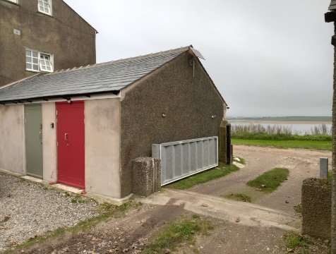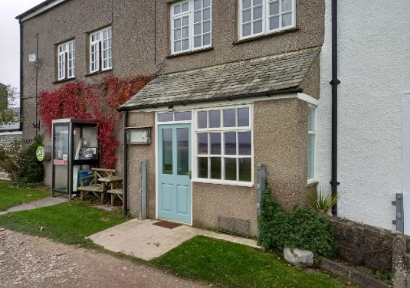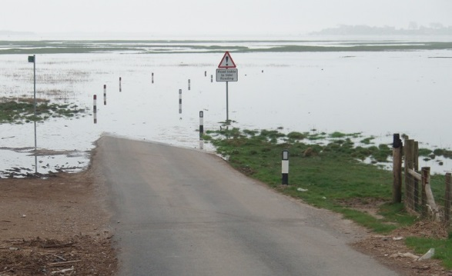

# Map

**

© Crown Copyright All rights reserved 10002543

# Contents (Sunderland Point)

|  |  |  |
| --- | --- | --- |
| **Section** | **Details** | **Page** |
|  | Plan ownership and distribution record | 4,5 |
|  | Version Control and amendment | 6 |
| 1 | Information | 7 |
| 1.1 | Sunderland Point | 25 |
| 1.2 | Map | 25 |
| 1.3 | Community Profile | 27 |
| 2 | Intention | 28 |
| 2.1 | Aim of the Community Emergency Scheme | 28 |
| 2.2 | Structure of the Community Emergency Scheme | 28 |
| 3 | Method | 29 |
| 3.1 | Community Response | 29 |
| 3.2 | Resources | 29 |
| 3.3 | Role of Agencies in Emergency Response:  Lancaster Constabulary, Lancaster Fire and Rescue, North West Ambulance Service,  HM Coastguard, Hospitals, Environment Agency, Lancaster City Council,  Lancashire County Council, Voluntary Agencies, United Utilities (Electricity and Water) | 30,31 |
| 3.4 | Ministers of religion and faith leaders | 31 |
| 3.5 | Incident checklists | 32 |
| 3.6 | Flood Alert | 32 |
| 3.7 | Flood Warning | 33 |
| 3.8 | Severe Flood Warnings | 34 |
| 3.9 | Met. Office Weather Warnings | 35,36 |
| 3.10 | Emergency Services responsibilities: HM Coastguard, Police, Fire and Rescue, Ambulance | 37,38 |
|  | Deployment Algorithm | 39 |
| 3.11 | Specialist emergency response resources | 40,41 |
| 3.12 | Immediate emergency incident attendance | 40,41 |
| 3.13 | Rescue incidents causeway and marshes | 41 |
| 3.14 | Utility failure | 42 |
| 3.15 | Other incidents | 42 |
| 4 | Administration of the Emergency Plan | 43 |
| 5 | Communications | 44 |
| 5.1 | Inoperable Airwave Talkgroup | 44 |
| 5.2 | Emergency Contacts (see Appendix A) | 45 |
| 5.3 | Public Information sources | 45,46 |
| 5.4 | Emergency Communications | 44,45 |
|  | Appendix A: Organisation and Community contact details | 59-63 |
|  | Appendix B: Community Resources | 46 |
|  | Appendix C: Map of possible Access Routes | 47 |
|  | Appendix D: Radio Protocol and Instructions | 48 |
|  | Logs and Policies | 49-58 |
|  | Confidential information | 59-64 |

# Section 1: Information

* 1. **See Map above**

# 1.2 Sunderland Point

**Sunderland Point is situated on a peninsula adjoining the River Lune estuary. The village is unique in Lancashire, if not North West England, in that the only access road is often covered by tidal water twice each day. Predicted tides of more than 8.0 metres (Liverpool Datum) normally make the public road across the marsh from Overton impassable. The highest tides can cover the road from about two hours before to about two and a half hours after high water. However, in 2009 an emergency off road track, slowly passable by small 4WD or tracked vehicles, was created and is an option that can be considered for access in some emergency situations.**

Parts of the village front onto the estuary and have always been vulnerable to storms and high tides but climate change and rising sea levels are increasing the frequency and severity of such occurrences. Severe weather has also affected electricity supplies in the past and may well do so again in the future.

Because the community cannot be easily accessed by emergency services and other support during high tides or severe weather it has been decided to produce a Community Emergency Plan detailing the ‘self-help’ actions the community can take when weather conditions delay immediate support to an emergency situation. The emergency services have contributed to this plan and detailed their agreed procedures for responding to incidents at Sunderland Point and on the causeway road and adjoining marshes.

The scheme is built around a “Community Contact” system whereby several members of the community have volunteered to act as contacts and act as links to the various agencies shown in this document.

The scheme is separated into several sections:

* Information – General background information
* Intention – What the plan is intended to achieve
* Method – How the scheme’s aims will be achieved
* Administration – of the scheme
* Communications – Radio, telephony etc.

# Community Profile

**Residents:** The population of the Sunderland Point community is approximately 55 accommodated in around 35 properties; three residents are of school age.

Most properties are residential only although one is a working farm and one family works in fishing. There are no commercial or business premises.

**Visitors:**  There are no caravan or camping sites within the area covered by this plan. The village is popular with visitors. Motorists usually arrive and depart during the periods between high tides but they occasionally are forced by the incoming tide to remain in the village until the road is passable again. However, the village is accessible by public footpath or bridleway during almost all tidal conditions. While the settled community makes few demands on the emergency services it is not uncommon for visitors to get lost or stuck or trapped by the rising tide and these situations all require an urgent response by the appropriate agency (agencies).

# Section 2: Intention

**2.1 Aim**

The aim of this plan is to provide a single source of local information to improve community resilience and provide an effective initial response in an emergency situation.

The specific emergency situations covered include:

* Tidal flooding
* Predicted severe or extreme weather (high winds etc.)
* Fire
* Medical Emergency
* Any emergency incidents requiring the attention of the emergency services when the public road is blocked
* Rescue incidents on the causeway road and adjoining marshes
* Utility failure

# 2.2 Structure of the community emergency scheme

The Civil Contingencies Service of Lancaster City Council has prepared the template of this plan and assisted the Sunderland Point community representatives to complete it. The scheme is **completely voluntary** and **there is no statutory duty to participate** but the community saw it as a positive step to take in improving their resilience.

The plan provides a framework for listing contact details, responsibilities and information about resources. It is intended to be of real help in taking-action at the onset of an emergency and also assist in dealing with day-to-day problems that can arise in remote communities.

The unusual geographic features of Sunderland Point have also made it necessary to agree special procedures for any emergency services response and these are shown at Sections 3.10, 3.11 and 3.12.

The plan does not give prescriptive responses to various incidents but does provide procedures for bringing together emergency responders so that a variety of resources are available to them, along with the best possible sources of specialist advice, allowing dynamic decisions to be taken to respond to the circumstances they are faced with. Emergency responders will follow the JESIP doctrine (Joint Doctrine: the interoperability framework for emergency services) when a multi-agency approach is required for an emergency situation.

# Section 3: Method

# 3.1: Community Response

Many of the situations covered in this plan do not arise without warning but are predicted in Environment Agency flood warnings or Met Office severe weather warnings and flash warnings.

Individual householders have well-rehearsed methods of protecting their properties when flooding is predicted, including the use of floodgates and storm boards, and of course also help their neighbours in preparing for predicted flooding.

This Sunderland Point Community Emergency Scheme builds on the existing individual preparations. It identifies resources available to all and uses the “Community Contact” system for links to/from external assistance.

# 3.2: Resources

**Mission Church (OS Map Reference SD 425560)**

It has been agreed with that the Mission Church can be used as an emergency muster point if such facilities are required for any incident that causes this plan to be activated. However, the church is not suitable to use as a community rest centre as it has no toilet and there is no comfortable seating or space for storage at present. For these reasons, evacuation of vulnerable people from Sunderland Point will always be considered when flood or severe weather warnings are received.

**Emergency equipment**

There is a programme within the community of encouraging residents to invest in personal emergency equipment, particularly wind-up torches, lamps, radios and phone chargers and also first aid kits.

In addition, an inventory has been made of ‘community’ held equipment and this is held by the Community Contacts.

# 3.3: Role of Agencies in emergencies

**Police:** The **Lancashire Constabulary** is responsible for the coordination of all other agencies at the scene of any emergency incident (other than those on the shoreline or off-shore when the Coastguard service has primacy). The police also have a role to investigate any possible criminal aspects of any incident.

**HM Coastguard** is responsible for the initiation and coordination of civil maritime search and rescue within the UK search and rescue region. This includes the mobilisation, organisation and tasking of adequate resources to respond to persons either in distress at sea, or to persons at risk of injury or death on the cliffs or shoreline of the UK.

**The Coastguard Service is the ‘gateway’ organisation to the RNLI, Bay Rescue and RAF search & rescue resources. These resources may also assist in inland emergencies including flooding.**

**Because the sea and the inter-tidal area is so dangerous the Coastguards must be informed of and consulted about any coastal or maritime incident – see emergency service procedures at Section 3.11.**

**Fire:** The **Lancashire Fire & Rescue Service** is responsible for fire-fighting and rescue. They are comprehensively equipped with search and rescue equipment, including specialist equipment for rescue from collapsed buildings. They also have access to high volume pumping equipment and may be asked to assist in flooding incidents.

Ambulance: **The** North West Ambulance Service **is responsible for providing First Aid to casualties at the scene of any emergency incident and transport of casualties to hospital. At any multi-agency incident the Ambulance Service is the ‘gateway’ organisation to the wider National Health Service meaning that, in an emergency, other agencies wishing to access any Health organisation will initially do so through the Ambulance service.**

**The** University Hospitals of Morecambe Bay NHS Trust **has a comprehensive plan for the treatment of casualties, at local hospitals. This includes the deployment of a Hospital Mobile Emergency Team.**

The **Environment Agency,** working in conjunction with the **Met Office,** has a particular responsibility for flooding forecast and warning and the identification of flood risk areas.

**Lancaster City Council** supports the emergency services at an incident by the provision of a Duty Emergency Incident Officer, Rest Centres, waste management operations and environmental protection advice along with engineering and building control services.

**Lancashire County Council** also has an Emergency Planning Duty Officer and also provides countywide services such as Highways and Adult & Children’s (Social) Services.

**Voluntary Organisations** offering their various skills to the communities of Lancashire in times of emergency include:

* **St. John Ambulance**
* **Salvation Army**
* **British Red Cross**
* **WRVS**
* **Salvation Army**
* **RSPCA**
* **Raynet (Radio Amateurs)**
* **Faith Groups**
* **Mountain Rescue Teams (who can be used at any incident where their ‘outdoor’ search skills or rescue equipment may be of benefit)**
* **Bay Rescue**

With the exception of the Mountain Rescue Teams and Bay Rescue, these voluntary organisations are coordinated in Lancashire by the County Council Emergency Planning Service and the initial contact point for any of the above organisations must be the County Emergency Planning Duty Officer, who can be contacted by the Lancaster City Council Duty Emergency Incident Officer or any of the ‘blue light’ services. The Mountain Rescue Teams are mobilised by the Force Incident Manager at Police Headquarters. Bay Rescue can be mobilised by the Coastguard or the Police.

Agencies supporting these organisations include: **Electricity (North West) Ltd,** who provide specialised assistance concerning electricity supplies; to continue to supply electricity; to liaise with other organisations for the provision of emergency supplies and the disconnection of cables that constitute a danger to life and property. **United Utilities (Water),** deal with the maintenance of water supplies and sewage disposal arrangements, repairs to water mains and the availability of emergency water supplies in an incident.

# 3.4: Ministers of religion and faith leaders

Ministers of religion are familiar with the problems of care within the community. They are experienced in leadership, organisation and counselling the sick.

Ministers with particular knowledge of the Sunderland Point community include:

Revd Lorraine Moffatt, St Helen’s Rectory, Chapel lane, Overton, tel. 01524 858234

Through the Lancashire Resilience Forum it is possible to access a much wider faith community if there are particular needs during or after an incident.

# 3.5: Incident Checklists

Residents have a responsibility to keep themselves informed and be aware of weather conditions that may result in tidal flooding or other disruption. Sources of this information include:

BBC – Countryfile forecast, Shipping forecast (LW)

Met Office – severe weather warning forecasts

Environment Agency – Floodwatch and Flood Warning systems including automated messages to landlines and/or mobile telephones

Local radio – broadcasts of Environment Agency flood watches and warnings

During periods when there is a low likelihood of flooding or poor weather residents will replenish emergency packs, check that equipment is working correctly, essential supplies restocked, fresh batteries obtained for equipment and defences maintained including oiling/greasing of mechanisms, restocking and safe/dry storage of sand-bags and clearing of drainage channels.

Where any Flood Alert, Flood Warning, Severe Flood Warning or Severe weather warning received is expected to affect Sunderland Point the Duty Emergency Incident Officer at Lancaster City Council will speak to a Community Contact and discuss any assistance that may be needed.

It must be borne in mind that Flooding or Severe Weather that is likely to affect Sunderland Point can also affect other areas of Lancashire and will place increased demands on the emergency services across the county.

# 3.6: Flood Alert[[1]](#footnote-1) – Sunderland Point

Flood Alert **- EA Definition: Flooding is possible. Be prepared**

**EA recommended Actions:**

* **Monitor local news and weather forecasts.**
* **Be aware of water levels near you.**
* **Be prepared to act on your flood plan.**
* **Check on the safety of pets and livestock.**
* **Charge your mobile phone**

**Additional Actions for Sunderland Point:**

* **Check that all essential supplies are in place and that batteries for equipment are working/charged**
* **Check neighbours and bring any vulnerable people or any other areas of concern to the attention of a Community Contact (See Appendix ‘A’).**
* **Contacts in turn to check whether any vulnerable residents wish to leave the point and bring this to the attention of the authorities and seek assistance as appropriate.**
* **Consider the installation of flood defence equipment**
* **Monitor weather and tidal information and respond to any predicted worsening of the situation.**

# 3.7: Flood Warning[[2]](#footnote-2) – Sunderland Point

Flood Warning **- EA Definition: Flooding is expected. Immediate action required**

**EA recommended Actions:**

* **Move cars, pets, food, valuables and important documents to safety.**
* **Get flood protection equipment in place.**
* **Turn off gas, electricity and water supplies if safe to do so.**
* **Be prepared to evacuate your home.**
* **Protect yourself, your family and help others.**
* **Act on your flood plan.**

**Additional Actions for Sunderland Point:**

* **Community Contacts to arrange monitoring of local indicators that may indicate worsening situation – including the tide starting to flow much earlier than expected, the tide reaching the road much earlier than expected or the wind moving round to the SW to W.**
* **Residents to check that all essential supplies are in place and that batteries for equipment are working/charged.**
* **Move vehicles and other equipment to higher ground.**
* **Check neighbours and bring any vulnerable people or any other areas of concern to the attention of a Community Contact (See Appendix ‘A’).**
* **Contacts in turn to check whether any vulnerable residents wish to leave the point and bring this to the attention of the authorities and seek assistance as appropriate. If any residents are driving people off the point and intending to return they will need to allow plenty of time to do so before the road is covered by the tide.**
* **Install flood defence equipment to protect properties and openings.**
* **Monitor weather and tidal information and respond to any predicted worsening of the situation.**

# 3.8: Severe Flood Warning[[3]](#footnote-3) – Sunderland point

Severe Flood Warning **- EA Definition: Severe flooding. Danger to life.**

**This warning will only be issued in conjunction with other responder agencies and will be based on the threat to people’s safety and not just ‘trigger levels’ of anticipated high tides.**

**EA recommended Actions:**

* **Collect things you need for evacuation.**
* **Turn off gas, electricity and water supplies if safe to do so.**
* **Stay in a high place with a means of escape.**
* **Avoid electricity sources.**
* **Avoid walking or driving through flood water.**
* **In danger call 999 immediately.**
* **Listen to the emergency services.**
* **Act on your flood plan.**

**Additional Actions for Sunderland Point:**

* **Consider evacuation from Sunderland Point – and if intending to leave inform the Community Contacts.**
* **Community Contacts to arrange monitoring of local indicators that may indicate worsening situation as for flood warning.**
* **If not evacuating - residents to check that all essential supplies are in place and that batteries for equipment are working/charged.**
* **Move vehicles and other equipment to higher ground.**
* **Check neighbours and bring any vulnerable people or any other areas of concern to the attention of a Community Contact (See Appendix ‘A’).**
* **Contacts in turn to check whether any vulnerable residents wish to leave the Point and bring this to the attention of the authorities and seek assistance as appropriate. Bearing in mind the criteria for issuing such a warning and the likely demands on the emergency services anyone who would be vulnerable in a severe flooding situation should be encouraged to seek alternative accommodation away from the village until the danger has passed.**
* **If residents are driving people off the point and intend to return they need to allow time to do so before the road is covered by the tide.**
* **Install flood defence equipment to protect properties and openings.**
* **Monitor weather and tidal information and respond to any predicted worsening of the situation.**

# 3.9: Met Office Weather Warnings

The Met Office warn the public and emergency services of severe or hazardous weather which has the potential to cause damage, widespread disruption and/or danger to life through our National Severe Weather Warning Service. This includes warnings about rain, snow, wind fog and ice.

These warnings are given a colour depending on a combination of both the likelihood of the event happening and the impact the conditions may have.

The basic messages associated with each of the colours are:

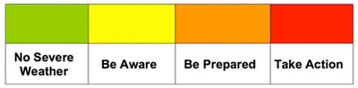

The basic message associated with each warning level is:

**Likelihood**

**High:** “You may need to take action as we are expecting….” “There will be….”

**Medium:** “We should be prepared for…” “There is likely to be…”

**Low:** “Be aware of the potential for/possibility of…” “There is a small chance of…”

**Very low:** “Be aware that there is a very small risk of…”

## What the colours mean

* **Yellow: Be aware. Severe weather is possible over the next few days and could affect you. Yellow means that you should plan ahead thinking about possible travel delays, or the disruption of your day to day activities. The Met Office is monitoring the developing weather situation and Yellow means keep an eye on the latest forecast and be aware that the weather may change or worsen, leading to disruption of your plans in the next few days.**
* **Amber: Be prepared.** **There is an increased likelihood of bad weather affecting you, which could potentially disrupt your plans and possibly cause travel delays, road and rail closures, interruption to power and the potential risk to life and property. Amber means you need to be prepared to change your plans and protect you, your family and community from the impacts of the severe weather based on the forecast from the Met Office**
* **Red: Take-action. Extreme weather is expected. Red means you should take action now to keep yourself and others safe from the impact of the weather. Widespread damage, travel and power disruption and risk to life is likely. You must avoid dangerous areas and follow the advice of the emergency services and local authorities.**

Severe weather warnings are available to you in a number of ways, meaning you can always access the latest information wherever you are. This includes on radio, TV, the Met Office website, social media, smart phone apps, RSS and via email alerts.

You can help by passing these warnings on to family and friends, or by sharing them on Facebook, Twitter and other social media with you friends and followers.

Weather warnings - likely to affect Sunderland Point.

**Apart from the risk of flooding the most likely scenario to affect Sunderland Point is a warning of high winds. At times of low risk of severe winds the community will endeavour to maintain properties in a good state of repair with particular attention to the maintenance of chimney stacks, general pointing of brickwork on buildings and walls, roof tiles and roofing felt and any bracketed equipment such as aerials and dishes. In addition, the condition of trees near to buildings, or anywhere else where they might cause disruption or injury if they fell, should be monitored and where necessary remedial action taken.**

If warnings are received of high winds consider the following:

**Ensure the security of loose objects, e.g. ladders, garden furniture or anything else that can be blown into windows and other glazing.**

**Close and securely fasten windows (and storm shutters if fitted), particularly those on the windward side of the house and especially large doors, i.e. garage / shed doors.**

**Park vehicles in a garage, if available, or keep them clear of buildings, trees, walls and fences.**

**Close and securely lock loft trap doors, particularly if roof pitch less than 30°.**

**If chimney stacks are tall and there are any doubts about their condition move beds from areas directly below them.**

During a storm the following actions may be appropriate and should be considered:

**Stay indoors as much as possible but if outside try to stay clear of buildings or trees**

**Keep away from the sheltered side of boundary walls and fences – if these structures fall they will collapse on this side.**

**Do not go outside to repair damage whilst storm is in progress**

**If possible enter and leave the house through doors on the sheltered side closing them behind you**

**Open internal doors only as needed and close them afterwards.**

Community Contacts **should endeavour to ensure that the above actions are implemented in the community and that any particular vulnerabilities are brought to the attention of the authorities.**

**There are 3 school aged children living at Sunderland Point. If for any reason they are unable to return home during a high tide or storm the usual response is for them to stay with relatives or friends until the road is passable again. If for any reason this arrangement was not available the County Council would be responsible for their care until their parents were able to collect them. (A full list of Community Contacts is shown at Appendix ‘A’ towards the rear of this plan)**

# 3.10: Emergency Services responsibilities

**The emergency services will use the JESIP doctrine when required to jointly respond to incidents on and around Sunderland Point.**

**HM Coastguard**

HM Coastguard is responsible for the initiation and coordination of civil maritime search and rescue within the UK search and rescue region. This includes the mobilisation, organisation and tasking of adequate resources to respond to persons either in distress at sea, or to persons at risk of injury or death on the cliffs or shoreline of the UK.

The Coastguard service will be advised of any incidents requiring emergency access to Sunderland Point and will give advice on whether the access road will be clear. If the road is not clear the arrangements outlined below will be initiated and the Coastguard Service will support the other responder agencies in bringing the incident to a safe conclusion.

**Police**

* **In the event of any incident requiring the attendance of any responder agency at Sunderland Point when the road is impassable the Police will coordinate the response.**
* **The police will also respond to all calls requiring their attendance at Sunderland Point, and if necessary seek the support of other agencies to afford them access in an emergency situation.**

**Fire and Rescue**

* Lancashire Fire and Rescue Service will respond to all calls to fires or other emergencies requiring their attendance at Sunderland Point, and if necessary seek the support of other agencies to afford them access in an emergency situation.
* Residents, on discovering a fire, should call the Fire Service via 999, leave the premises, and not return until given the all clear.
* The Fire Service will respond to requests from residents regarding Home Fire Safety Checks, fitting smoke detectors and advice on fire plans for every occupant.
* The Fire Service will ensure that crews can gain access to Sunderland Point at all times with all necessary equipment to perform their role and assist a return to normality.

**Medical Emergency**

**The North West Ambulance Service NHS Trust (NWAS) provides pre-hospital medical care and transportation across the North West. Where NWAS resources alone cannot ensure that this provision can be maintained for any reason, NWAS will engage with partner agencies and other groups or individuals who may be in a position to assist in the mitigate of the risk associated to the lack or delay in response to provide that level of care at the earliest opportunity.**

**Due to the geographic location of Sunderland Point, and the available access routes, the response to incidents within that locality may be hindered primarily due to access restrictions. NWAS recognises the importance of early clinical intervention as a contributory factor to the survivability of a patient suffering life-threatening conditions. In order to provide early intervention, NWAS supports Community First Responder (CFR) groups, one of which is located at Overton, to provide potentially life-saving treatment prior to the arrival of NWAS resources or evacuation by partner agencies to the Royal Lancaster Infirmary.**

**There is a defibrillator housed to the immediate south of the public telephone box on Second Terrace.**

**Where physical response cannot be achieved to Sunderland Point due to weather conditions or tide height without external assistance, NWAS will:**

* **Coordinate the medical response by partners to any medical or trauma-related incident.**
* **Deploy Community First Responders based at Sunderland Point to provide early life-saving assistance**
* **Where available, deploy air ambulance resources or seek the assistance of MOD Search and Rescue Helicopter resources.**
* **Where appropriate, seek the assistance of RNLI / Coastguard to attempt evacuation of the casualty to a rendezvous point**

**Should an incident occur at Sunderland Point requiring a medical response or medical evacuation, NWAS will employ the following algorithm utilising its own resources and those of those partners to ensure that appropriate levels of patient care are provided at the earliest opportunity.**

# NWAS Sunderland Point deployment algorithm – May 2016



# 3.11: Specialist Resources available for emergency response

**The following specialist resources are owned by various responder agencies but can be made available to support the response to any situation for which they are best suited, as jointly decided by the respective agency commanders responding to the incident.**

* RNLI **inshore rescue boat and hovercraft, the latter usually launched from the road at Snatchems (Golden Ball Hotel).**
* LFRS **4x4 ‘Crew-cab’ vehicle able to carry personnel and/or equipment.**
* Bay Rescue **Haggalund tracked vehicles able to carry personnel and/or equipment across farmland. This organisation also has other specialist equipment and vehicles. Bay Rescue can be mobilised by the police or Coastguard.**
* HM Coastguard **4x4 and All-Terrain Vehicles based at Knott End.**
* NWAS **air ambulance.**
* Police **air support helicopter.**
* SAR **helicopter.**

**Commanders will take account of prevailing weather, tidal and ground conditions in determining the resources best suited to the task in hand.**

3.12 Incidents requiring the immediate attendance of an Emergency Service to Sunderland Point village.

**The public road to Sunderland Point can be considered impassable for a period from up to two hours before and up to two and a half hours after a high tide of eight metres or more (Liverpool Datum applies), in average weather conditions. Please consult Sunderland Point Community Contacts for more information.**

**Where any Police, Fire or Ambulance vehicle is deployed to an incident requiring immediate attendance at Sunderland Point the relevant Control Centre will contact HM Coastguard General Operations Centre (0151 931 3341) and ask whether it is safe for the vehicles to access the village. Advice on safe crossing can also be obtained from any of the Community Contacts listed in Appendix ‘A’.**

**Where an incident requires attendance during a high tide a number of options are now available to the emergency services including the specialist resources listed at 3.11 above and could also consider:**

* **Access on foot using footpaths across farmland.**
* **Possible use of Mountain Rescue Team resources.**

Rendezvous Point: **Many factors including the current or recent weather, the nature of the incident, the time of day etc mean that emergency services commanders will need to decide the most appropriate means of accessing the village. To allow these decisions to be made it has been agreed that responding agencies will rendezvous on Mellishaw Lane river-bank (Map Ref. SD 451618), near The Golden Ball at Snatchems, so that any response to an incident is coordinated and the best use made of all available resources. Where appropriate a second Forward Command Point (FCP) can additionally be established on the car park of The Globe Hotel at Overton (Map Ref. SD 433578).**

**Communications**

Interoperable Airwave communications should be established with a command channel for the incident commanders of the various services using the Emergency Services talkgroup: PLANC-ES1. HMCG may additionally establish Marine Band communication channels.

**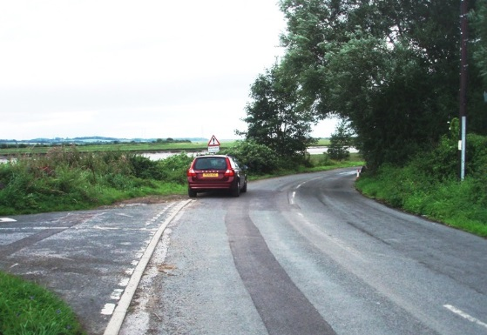**

**Snatchems Forward Command Point**

# 3.13: Water Rescue incidents on the causeway and adjoining marshes

**Incidents of persons needing rescuing from tidal waters on the causeway access road or the adjoining marshes occur quite regularly and require immediate attention as lives are usually in danger.**

**Such incidents may be reported to the police, fire service, ambulance or coastguard and, following previous incidents, it has been agreed that the following procedures will apply:**

* **The emergency service receiving the call will immediately notify the known circumstances to the other three services.**
* **HM Coastguard will in turn notify the RNLI at Morecambe.**
* **The Rendezvous and Forward Command Point (FCP) for rescue incidents on the causeway and marshes will be the Globe Inn at Overton unless circumstances dictate otherwise. The flood defence embankment here provides a vantage point from where the entire causeway road can be seen. (Note that if the RNLI hovercraft is being used it will need to launch from Snatchems but this does not affect the location of the FCP)**
* **The senior officers present from all four services will liaise at the FCP and pool information. HM Coastguard will coordinate the services who will agree the appropriate response based on the circumstances at the time and the resources available to them** (See 3.11 above).
* **Interoperable Airwave communications should be established with a Command channel for the incident commanders of the various services using the Emergency Services talkgroup: PLANC-ES1. HMCG may also establish Marine Band communication channels**

**Community Contacts from Sunderland Point will be able to give local advice and information about the tide and weather conditions. Dependant on the location of the incident they may also be able to give information on what can be seen from the village end of the causeway. The Emergency Services may choose to telephone any of the Community Contacts listed in Appendix ‘A’ towards the rear of this plan to see if they are able to relay any information that will assist the early resolution of the incident. However it must be made clear to them that they should not put themselves in any danger to obtain the information.**

**If any residents of Sunderland Point feel they have information that will assist a rescue but have not been contacted by any emergency service they can make telephone contact with the appropriate emergency service using any of the numbers contained in the Contacts section of this plan.**

# 3.14: Utility Failures

**Power Blackout**

In the event of electricity supply failure residents should ring the Electricity North West Limited control centre in the normal way to report the problem. This allows the Control centre to assess the nature and scale of the breakdown.

If it becomes apparent to any members of the community that the power cut is widespread or likely to become protracted they should convey that information to a Community Contact to consider what action is necessary to support the community, particularly any vulnerable members and whether to activate the emergency plan. The City Council Duty Emergency Incident Officer (DEIO) should also be contacted, via the Council’s Emergency Call Centre.

If it is necessary to contact the Electricity North West Limited Emergency Control Centre Manager for further information the DEIO will do this on behalf of the community.

**Water Supply disruption**

In the event of a water supply failure residents should ring the United Utilities (Water) control centre in the normal way to report the problem. This allows the Control centre to assess the nature and scale of the supply breakdown.

If it becomes apparent to any members of the community that the water supply problems are widespread or likely to become protracted they inform a Community Contact to consider what action is necessary to support the community, particularly any vulnerable members and whether to activate he emergency plan. The City Council Duty Emergency Incident Officer (DEIO) should also be contacted, via the Council’s Emergency Call Centre.

If it is necessary to contact the United Utilities Emergency Control Centre Manager for further information the DEIO will do this on behalf of the community. The DEIO has the necessary information and contacts to organise alternative water supplies, for drinking and for sanitation, in an emergency.

# 3.15: Other incidents

**A plan of this nature can never cover all situations. In the event of any other type of emergency occurring the community will seek assistance through the usual channels and if necessary use the services of the Community Contacts to coordinate the local response and to call on any of the organisations outlined in this plan.**

# Section 4: Administration of the Emergency Plan

This plan has been produced by the community in association with the Civil Contingencies Officer at Lancaster City Council and locally based emergency services representatives. It has been quality assured by Lancashire County Council Emergency Planning Service. The Coordinator and the other Community Contacts are responsible for keeping the plan up to date. The plan will be reviewed at least annually or after any activation.

The plan is available for any member of the community to read and the planners welcome any observations on how it may be improved.

The Community Contacts also have (with permission) a record of the contact details of community members along with information about any residents who may be considered vulnerable (including temporary vulnerabilities). These details are retained separately from the main plan under secure conditions in the community but not by any other agency.

# Section 5: Communication methods

* 1. **Interoperability Airwave Talkgroup**

During multi-agency response incidents interoperable Airwave communications should be established with a Command channel for the incident commanders of the various services using the Emergency Services Talkgroup: PLANC-ES1. HMCG may also establish Marine Band communication channels.

* 1. **Emergency Radio use see protocol appendix D**
  2. **Contact details for agencies and organisations**

These are shown at Appendix “A”

**5.4 Public Information**

The local radio and television will carry severe weather warnings, advice to the public and emergency telephone numbers. In the event of a power cut a wind-up, battery operated or car radios should be used to monitor broadcasts.

The radio stations also have up to date information on their websites about emergency situations

Local Radio Stations

|  |  |  |
| --- | --- | --- |
| **Station** | **Frequency** | |
| **FM** | **Website** |
| BBC Radio Lancashire  In an emergency situation Radio Lancashire halts its regular transmissions and moves to its public information role known as “Connecting in a Crisis” | 103.9, 95.5, 104.5 and DAB Digital Radio | [www.bbc.co.uk/lancashire](http://www.bbc.co.uk/lancashire) |
| Beyond Radio | 103.5 FM and 107.5 FM | [www.beyondradio.co.uk](http://www.beyondradio.co.uk) |

# 5.3 Emergency Communications for the Community

Landline and mobile telephony is available at the village, and mobile reception has steadily improved in recent years on most networks.

When the Community Contacts are discussing any anticipated situation with the City Council’s Duty Emergency Incident Officer all options for maintaining contact will be considered and an appropriate method determined in advance.

|  |  |  |  |
| --- | --- | --- | --- |
| Organisation and Community Contact Details Appendix ‘A’ | | | |
| Organisation | Address | Tel No: 1 | Tel No:2 |
| **Emergency Services and other responder agencies** | | | |
| Lancashire Constabulary (HQ) | Hutton, Preston  PR4 5SB | 01772 614444 |  |
| Lancashire Constabulary  West Division | Via Police Control Centre, Hutton | 999 (Emergency) or  101 (Non-emergency) | 0845 1253545 |
| Lancashire Fire & Rescue | North West Fire Control, Warrington | 999 or  01925 460841 | 01524 411590  (Morecambe Fire Station) |
| North West Ambulance Service | 449-451 Garstang Rd, Broughton, Preston PR3 5LN | 999 or  01772 867707 |  |
| HM Coast Guard  (Sea and Cliff Rescue) |  | 999 or  0151 931 3341 (24 hour General Operations Centre) | 0151 931 3343 (24 hour General Operations Centre) |
| RNLI | Morecambe | RNLI resources must be mobilised by Coastguard | |
| Bay Rescue | Milnthorpe and other locations | Bay Rescue resources must be mobilised by the Coastguard or the Police | |
| Environment Agency | Lutra House, Preston | 01772 714110 | 0800 807 060 (Incident Hotline) |
| DEFRA |  | 08459 33 55 77 | Floodline 08459 881188 |
| Met Office |  | 0870 900 0100 |  |

|  |
| --- |
| **Medical** |

|  |  |  |  |  |
| --- | --- | --- | --- | --- |
| Lancaster Royal Infirmary | Lancaster | | 01524 65944 |  |
| Emergency/Out of Hours GP service  Baycall (6pm-8am, W/Ends and BHs) |  | | 01539 718999 |  |
| Evening/Night District Nursing Service |  | | 01524 405722 |  |
| NHS Direct |  | | 0845 46 47 |  |
| **Local Authorities** | | | | |
| Lancaster City Council | | Lancaster & Morecambe | 24hr Call Centre  01524 67099  (Contact for Duty Officer) | Civil Contingencies Officer  01524 582680 |
| Lancashire County Council  (Emergency Planning Service) | | Preston | 01772 537902 | “Out of hours” callers will be given another number to ring for assistance. |
| **Public Utilities** | | | | |
| Electricity North West Limited | | For customers re loss of electricity | **0800 195 4141** |  |
| Water (United Utilities) | | Water & Wastewater | 0845 746 2200 |  |
| Telephones (British Telecom) | | Telephone lines | 0800 800 151 |  |
| **Community Contacts** | | | | |
| William Morris  Elizabeth Gilchrist  Katharine Green  Ted Levey  Lynne Levey  Alan Smith | |  | N/A  N/A  N/A  01524 858442  01524 858442  01524 858784 | 07527 124777  07790 611262  07875 249713  07434 736067  07944 991876  N/A |

**Appendix ‘B’ Resources in the community**

An equipment and resources inventory has been compiled but is not detailed in this plan, owing to frequent amendments being anticipated. The list also identifies the equipment that requires specialist training or skill to operate.

The inventory is being maintained separately by a nominated keeper who is resident on Sunderland Point, and will able to maintain the list for use emergency situations.

**People with Special Skills**

The Community Contacts are aware of the residents with particular skills that they can call on for different situations.

**Appendix ‘C’**

Map of possible land access routes

Overton members available to assist with route (mobile 07917 181060)

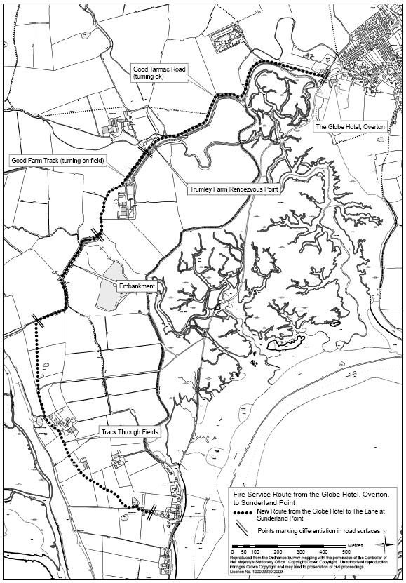+

**Appendix ‘D’**

ERAL Radio Simple Guide

1. Switch on using the smaller of the toggle switches on the top
2. Use the middle rotating knob to ensure that the radio is set to Digital (3 settings county, analogue and digital)
3. Use the 2 small buttons at the side to select the channel (Lancaster if in Lancaster and Morecambe if Morecambe) the channels are separate, so everyone needs to be on the same channel.
4. Press the P2 button until it beeps – this will keep the selection locked and means even if you knock the channel button you won’t move from the one you selected.
5. Switch on using the smaller of the toggle switches on the top
6. Use the middle rotating knob to ensure that the radio is set to Digital (3 settings county, analogue and digital)
7. Use the 2 small buttons at the side to select the channel (Lancaster if in Lancaster and Morecambe if Morecambe) the channels are separate, so everyone needs to be on the same channel.
8. Press the P2 button until it beeps – this will keep the selection locked and means even if you knock the channel button you won’t move from the one you selected.
9. Switch on using the smaller of the toggle switches on the top
10. Use the middle rotating knob to ensure that the radio is set to Digital (3 settings county, analogue and digital)
11. Use the 2 small buttons at the side to select the channel (Lancaster if in Lancaster and Morecambe if Morecambe) the channels are separate, so everyone needs to be on the same channel.
12. Press the P2 button until it beeps – this will keep the selection locked and means even if you knock the channel button you won’t move from the one you selected.

# Policies

The Overton Emergency Plan Risk Policy (To be completed as appropriate)

|  |  |  |
| --- | --- | --- |
|  | **Section heading** | **Section content** |
| 1 | **Responsibility** | The Overton Emergency Plan Working Party has overall and final responsibility for Risk Assessment. |
| 2 | **What are the hazards?** |  |
| 3 | **Who might be harmed and how?** |  |
| 4 | **What are you already doing?** |  |
| 5 | **Do you need to do anything else to control this risk?** |  |
| 6 | **Action by whom?** |  |
| 7 | **Action by when?** |  |
| 8 | **Confirmation of reading** | I confirm that I have been made fully aware of, and understand the contents of, the Risk Assessment Policy and Procedures for The Overton Emergency Plan.  Name :    Signature:  Date: |
| Signature: Date: | | |

Overton Emergency Plan Risk assessment template Date \_\_\_\_\_\_\_\_\_\_\_\_\_\_\_

|  |  |  |  |  |  |  |  |
| --- | --- | --- | --- | --- | --- | --- | --- |
| **What are the hazards?** | **Risk level**  **Low**  **Moderate**  **High** | **Who might be harmed and how?** | **What are you already doing?** | **Do you need to do anything else to control this risk?** | **Action by who?** | **Action by when?** | **Done** |
| Example:  Slips and trips | As appropriate | Volunteers may be injured if they slip on icy paths. | Reminding volunteers to use caution and ensure appropriate footwear | Clear paths if appropriate. | All staff, supervisor to monitor  Manager | From now on |  |
|  |  |  |  |  |  |  |  |
|  |  |  |  |  |  |  |  |
|  |  |  |  |  |  |  |  |

The Overton Emergency Plan Health and Safety Policy

|  |  |
| --- | --- |
| 1 | The Overton Emergency Plan Group has overall and final responsibility for health and safety. |
| 2 | Prevent accidents and cases of work-related ill health by managing the health and safety risks of members and volunteers. |
| 3 | Provide clear instructions and information, and adequate training, to ensure emergency coordinators and volunteers are competent to do their work |
| 4 | Engage and consult with emergency coordinators and volunteers on health and safety conditions and concerns. |
| 5 | Implement emergency procedures – evacuation in case of fire or other significant incident. |
| 6 | Maintain safe and healthy working conditions, provide and maintain equipment and ensure safe storage and use of resources. |
| 7 | This policy to be reviewed at least every year and updated as necessary. |
| 8 | I confirm that I have been made fully aware of, and understand the contents of, Health and Safety Policy and Procedures for The Overton Emergency Plan.  Name :    Signature:  Date: |
| Signed: Date: | |

The Overton Emergency Plan Vulnerable Adult Policy

|  |  |
| --- | --- |
| **Section heading** | **Section content** |
| 1. **Introduction** | The Overton Emergency Plan makes a positive contribution to a strong and safe community and recognises the right of every individual to stay safe.  The Overton Emergency Plan working group members, coordinators and other volunteers may come into contact with vulnerable adults through the offer of support in a village emergency or through the Help card being displayed hence acted upon.  The types of contact with vulnerable adults will include emergency support in the absence of professional agencies.  This policy seeks to ensure that The Overton Emergency Plan Group undertakes its responsibilities with regard to protection of vulnerable adults and will respond to concerns appropriately. |
| 1. **Definitions** | Safeguarding is about ensuring the protection of vulnerable adults wherever possible.  Abuse can take a number of forms, including the following:   * + Physical abuse   + Sexual abuse   + Emotional abuse   + Bullying   + Neglect   + Financial (or material) abuse   Definition of Vulnerable Adults  A vulnerable adult is a person aged 18 years or over who may be unable to take care of themselves or protect themselves from harm or from being exploited.  This **may** include a person who:   * Is elderly and frail * Has a mental illness including dementia * Has a physical or sensory disability * Has a learning disability * Has a severe physical illness * Is a substance misuser * Is homeless |
| 1. **Responsibilities** | Each person has a responsibility to follow the guidance laid out in this policy and related policies, and to pass on any welfare concerns using the required procedures.  **Additional specific responsibilities**  The Overton Emergency Plan Group members will endeavour to ensure  that this policy is read and followed by all involved in its work for the village.  Lla |
| 1. **Implementation Stages** | The scope of this Safeguarding Policy is broad ranging and in practice it will be implemented via an implicit respect for the dignity of every individual and through putting into action the contents of this policy.  **Safe recruitment**  The Overton Emergency Plan Group members will ensure that volunteers are suitably selected and are equipped and trained for their roles. |
| 1. **Communications, training and support for staff** | **Induction** will include briefing followed by reading and accepting this policy.  **Support**  We recognise that involvement in certain situations can be stressful for individuals concerned.  It is fundamentally important that all volunteers feel that they are supported by every member of our group and feel able to report back concerns and that these concerns be appreciated, understood and acted upon.  Volunteers should feel comfortable in what they do and should recognise the appropriate balance between supporting an individual yet ensuring the correct detachment is kept in place. |
| 1. **Professional boundaries and Reporting** | The following professional boundaries must be adhered to:   * Always act in pairs or groups. * Ensure that a coordinator is aware of your task and of where you are. * Always report back to a coordinator and ensure that a log is made of your visit and tasks. * Always report any concern or health and safety issue that you are aware of and ensure that it has been logged. |
| 1. **Managing information** | Information will be gathered, recorded and stored.  Relevant information will be forwarded to the Council and/or appropriate professional bodies.  All staff must be aware that they have a professional duty to share information with other agencies in order to safeguard vulnerable adults.  The public interest in safeguarding vulnerable adults may override confidentiality interests.  All staff must be aware that they cannot promise those they support that they will keep secrets. |
| 1. **Reviewing the policy** | This policy will be reviewed, and if necessary updated, by The Overton Emergency Plan Group at least once a year. |
| 1. **Confirmation of reading** | I confirm that I have been made fully aware of, and understand the contents of, the Safeguarding Policy and Procedures for The Overton Emergency Plan.  Name :    Signature:  Date: |

Overton and Sunderland Point have volunteers who, in a local emergency or difficult situation, will offer to assist and coordinate help.

Overton Emergency Plan – Help Needed Sign

If you need help place this sign with the H facing outward, in a front window.

Should you see one of these signs displayed please offer assistance and/or

call the Emergency Plan Group on 07396 699871

As always, in serious situations ring 999

Other less urgent needs:

use your H sign; ask neighbours / passers-by for assistance.

ring the Emergency Group phone number for help 07917 181060

Contact the Lancaster Community Hub on 01524 582000

or copy the link: <https://www.lancaster.gov.uk>

then choose “Community Hub”

Website: overtonemergencyplan.wixsite.com/overtonemergencyplan

Defibrillators are situated outside of the Memorial Hall,

outside (roadside) of St. Helen's Church, the Globe car park and on the wall between Church Park and Chapel View, Sunderland Point Reading Room wall.

All Things Overton Facebook and The Parish Councils are excellent and supportive community resources

In an emergency or serious situation (such as a utilities problem or weather emergency) the Overton and District Memorial Hall may be used as the primary emergency centre as may the Sunderland Point Reading Room and Mission Church

Emergency Group mobile number 07917 181060

The NATO Phonetic Alphabet

|  |  |  |
| --- | --- | --- |
| Letter: | Code Word: | Pronunciation: |
| A | Alpha | Al fah |
| B | Bravo | Brah Voh |
| C | Charlie | Char Lee |
| D | Delta | Dell Tah |
| E | Echo | Eck Oh |
| F | Foxtrot | Foks Trot |
| G | Golf | Golf |
| H | Hotel | Hoh Tell |
| I | India | In Dee Ah |
| J | Juliett | Jew Lee Ett |
| K | Kilo | Key Loh |
| L | Lima | Lee Mah |
| M | Mike | Mike |
| N | November | No Vem Ber |
| O | Oscar | Oss Car |
| P | Papa | Pah Pah |
| Q | Quebec | Keh Beck |
| R | Romeo | Row Me Oh |
| S | Sierra | See Air Ah |
| T | Tango | Tang Go |
| U | Uniform | You Nee Form |
| V | Victor | Vik Tah |
| W | Whiskey | Wiss Key |
| X | X Ray | Ecks Ray |
| Y | Yankee | Yang Key |
| Z | Zulu | Zoo Loo |

Community Emergency Log Form Overton Emergency Plan

**Reference Number \_\_\_\_\_\_** *Please complete using ballpoint pen and print clearly throughout.*

|  |  |
| --- | --- |
| **Information source** Name, phone number, email, media, etc. |  |
| **Information** |  |
|  | Date: Time: |
|  | Name and signature: |

|  |  |  |
| --- | --- | --- |
| **Risk Assessment**  Who / what is at risk |  |  |
| **Action**  Safe and Achievable |  |  |
| **Team** Members & Contact Details. |  |  |
| **Task sheet issued** | Yes/No |  |
| **Team** Briefed & Committed | Date: Time:  Name and signature: |  |

|  |  |  |  |  |
| --- | --- | --- | --- | --- |
| **Team(s)** | **Returned** | Yes/No | **Debriefed** | Yes/No |
| **Further Action** |  | | | |
|  | Date: Time: | | | |
|  | Name and signature: | | | |

|  |  |
| --- | --- |
| Distribution | Emergency Log (when completed) |

Community Emergency Task Sheet

*Please complete using ballpoint pen and print clearly throughout.*

**Reference Number** \_\_\_\_\_

This should be the same as the relevant community emergency log form number, with A, B, C, etc. added as required

**Team members**

\_\_\_\_\_\_\_\_\_\_\_\_\_\_\_\_\_\_\_\_\_\_\_\_\_\_\_\_\_\_\_\_\_\_\_\_\_\_\_\_\_\_\_\_\_\_\_\_\_\_\_\_\_\_\_\_\_\_\_\_\_\_\_\_\_\_\_\_\_\_\_\_\_\_\_\_\_\_\_\_\_\_\_\_\_\_\_\_\_\_\_\_\_\_\_\_\_\_\_\_\_\_\_\_\_\_\_\_\_\_\_\_\_\_\_\_\_\_\_\_\_\_\_\_\_\_\_\_\_\_\_\_\_\_\_\_\_\_\_\_\_\_\_\_\_\_\_\_\_\_\_\_\_\_\_\_\_\_\_\_\_\_\_\_\_\_\_\_\_\_\_\_\_\_\_\_\_\_\_\_\_\_\_\_\_\_\_\_\_\_\_\_\_\_\_\_\_\_\_\_\_\_\_\_\_\_\_\_\_\_\_\_\_\_\_\_\_\_\_\_\_\_\_\_\_

**Emergency contact details**

Emergency Centre \_\_\_\_\_\_\_\_\_\_\_\_\_\_\_\_\_\_\_\_\_\_\_\_\_\_\_\_\_\_\_\_\_\_\_\_\_\_\_\_\_\_\_\_\_\_\_\_\_\_\_\_

Team \_\_\_\_\_\_\_\_\_\_\_\_\_\_\_\_\_\_\_\_\_\_\_\_\_\_\_\_\_\_\_\_\_\_\_\_\_\_\_\_\_\_\_\_\_\_\_\_\_\_\_\_

Other \_\_\_\_\_\_\_\_\_\_\_\_\_\_\_\_\_\_\_\_\_\_\_\_\_\_\_\_\_\_\_\_\_\_\_\_\_\_\_\_\_\_\_\_\_\_\_\_\_\_\_\_

*All community emergency team members / volunteers / helpers should make every effort not to put themselves or others at Risk or in Danger.*

Task

\_\_\_\_\_\_\_\_\_\_\_\_\_\_\_\_\_\_\_\_\_\_\_\_\_\_\_\_\_\_\_\_\_\_\_\_\_\_\_\_\_\_\_\_\_\_\_\_\_\_\_\_\_\_\_\_\_\_\_\_\_\_\_\_\_\_\_\_\_\_\_\_\_\_\_\_\_\_\_\_\_\_\_\_\_\_\_\_\_\_\_\_\_\_\_\_\_\_\_\_\_\_\_\_\_\_\_\_\_\_\_\_\_\_\_\_\_\_\_\_\_\_\_\_\_\_\_\_\_\_\_\_\_\_\_\_\_\_\_\_\_\_\_\_\_\_\_\_\_\_\_\_\_\_\_\_\_\_\_\_\_\_\_\_\_\_\_\_\_\_\_\_\_\_\_\_\_\_\_\_\_\_\_\_\_\_\_\_\_\_\_\_\_\_\_\_\_\_\_\_\_\_\_\_\_\_\_\_\_\_\_\_\_\_\_\_\_\_\_\_\_\_\_\_\_\_\_\_\_\_\_\_\_\_\_\_\_\_\_\_\_\_\_\_\_\_\_\_\_\_\_\_\_\_\_\_\_\_\_\_\_\_\_\_\_\_\_\_\_\_\_\_\_\_\_\_\_\_\_\_\_\_\_\_\_\_\_\_\_\_\_\_\_\_\_\_\_\_\_\_\_\_\_\_\_\_\_\_\_\_\_\_\_\_\_\_\_\_\_\_\_\_\_\_\_\_\_\_\_\_\_\_\_\_\_\_\_\_\_\_\_\_\_\_\_\_\_\_\_\_\_\_\_\_\_\_\_\_\_\_\_\_\_\_\_\_\_\_\_\_\_\_\_\_\_\_\_\_\_\_\_\_\_\_\_\_\_\_\_\_\_\_\_\_\_\_\_\_\_\_\_\_\_\_\_\_\_\_\_\_\_\_\_\_\_\_\_\_\_\_\_\_\_\_\_\_\_\_\_\_\_\_\_\_\_\_\_\_\_\_\_\_\_\_\_\_\_\_\_\_\_\_\_\_\_\_\_\_\_\_\_\_\_\_\_\_\_\_\_\_\_\_\_\_\_\_\_\_\_\_\_\_\_\_\_\_\_\_\_\_\_\_\_\_\_\_\_\_\_\_\_\_\_\_\_\_\_\_\_\_\_\_\_\_\_\_\_\_\_\_\_\_\_\_\_\_\_\_\_\_\_\_\_\_\_\_\_\_\_\_\_\_\_\_\_\_\_\_\_\_\_\_\_\_\_\_\_\_\_\_\_\_\_\_\_\_\_

Date \_\_\_\_\_\_\_\_\_ Time \_\_\_\_\_\_\_ Name & Signature \_\_\_\_\_\_\_\_\_\_\_\_\_\_\_\_\_\_\_\_\_\_\_\_\_\_\_\_\_

*Distribution:*

Top copy to community emergency personnel undertaking the task.

Bottom copy to be kept with relevant emergency log form.

**Community Emergency Training Element and Authorisation**

Overton Emergency Plan

\_\_\_\_\_\_\_\_\_\_\_\_\_\_\_\_\_\_\_\_\_\_\_\_ (name) has successfully completed the community

emergency training elements below and is authorised as a coordinator.

Authorising officer:

Name \_\_\_\_\_\_\_\_\_\_\_\_\_\_\_\_\_\_\_\_\_\_\_\_\_\_\_\_\_

Signature \_\_\_\_\_\_\_\_\_\_\_\_\_\_\_\_\_\_\_\_\_\_\_\_\_\_\_\_\_

Date \_\_\_\_\_\_\_\_\_\_\_ \_\_\_\_\_\_\_\_\_\_\_

|  |  |  |
| --- | --- | --- |
| Section | Element | Completed |
| 1 | Policies / Confidentiality / Health & Safety |  |
| 2 | Initial Actions |  |
| 3 | Visit and familiarisation of the Emergency Centre(s) |  |
| 4 | Emergency log keeping |  |
| 5 | Roles in the emergency centre |  |
| 6 | Communication and information gathering |  |
| 7 | Planning the response using the emergency log form |  |
| 8 | Liaise with & support  - emergency services / professional support/ City Council |  |
| 9 | Temporary shelter / evacuation |  |
| 10 | Area specific information and the location of supplementary emergency plan information |  |
| 11 | Questions and close |  |

Notes

This training record should be kept by an appropriate person / group / council,

please specify: \_\_\_\_\_\_\_\_\_\_\_\_\_\_\_\_\_\_\_\_\_\_\_\_\_\_\_\_\_\_\_\_\_\_\_\_\_\_\_\_\_\_\_\_\_\_

# Confidential Section

n/a Please contact [mctague.michael@gmail.com](mailto:mctague.michael@gmail.com)

1. *The new Flood Alert code replaced the original term Flood Watch on 30.11.2010.*  [↑](#footnote-ref-1)
2. *This definition was amended on 30.11.2010* [↑](#footnote-ref-2)
3. *This definition was amended on 30.11.2010*  [↑](#footnote-ref-3)